ECE 383 Vivado Installation

# Overview

This document shows you how to install and license a copy of Xilinx Vivado, along with installing the required board support files. Pictures show the 2016.4 version.

# What you need before starting

1. **Hard disk space** – Plan on the installation requiring approximately 22 GB.
2. **Installation files** (approximately 18GB) – Provided in class with an external hard drive. You do not need to copy them to your computer; you can run them from the hard drive.
   1. **Not required if only adding SDK to a previous installation**
3. **Admin access** – make sure your cadet admin account is available
4. **Time** – Plan on *at least* 30 minutes

# Vivado Installation

If you are simply adding SDK or other features to a previous Vivado installation, click on in your Windows Start Menu.

Otherwise, navigate to the Vivado installation files on the provided external hard drive and **run xsetup.exe** in the Xilinx_2016.4 folder (admin privileges required). Optionally, you can instead download roughly 18GB of installation files.

In both cases, you should see a lovely splash screen like the below image. Take a one minute nap while the installer loads. Cancel the request to poke a hole in your firewall, if any should pop up.



Users upgrading Vivado can now skip to the Edition Selection on page 3.

For new installs, **Click** **Continue** to install 2016.4 instead of downloading 2017.1+, unless you want to download files for hours just for new-fangled goodness that is unnecessary for this class.

**Click Next** at the following screen.

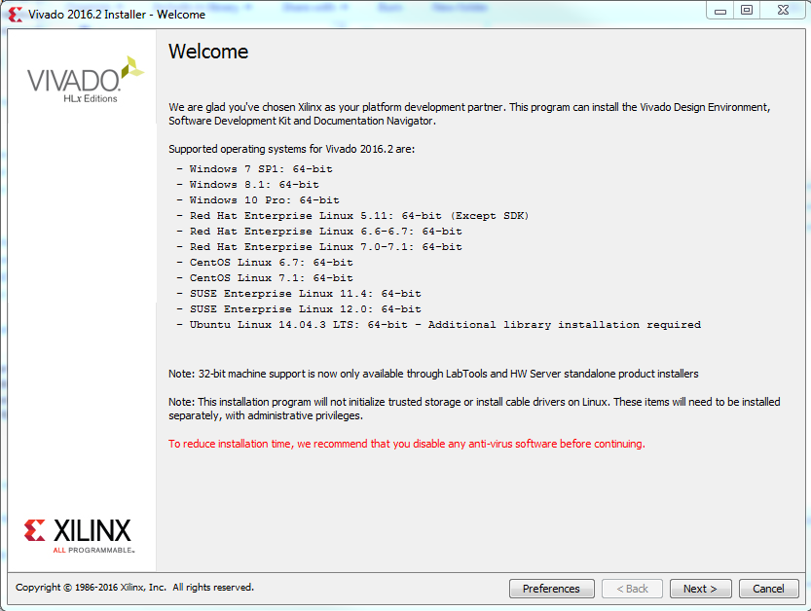

**Check “I Agree”** for all of the terms so you can be owned by lawyers if anything happens. Then **Click Next**.

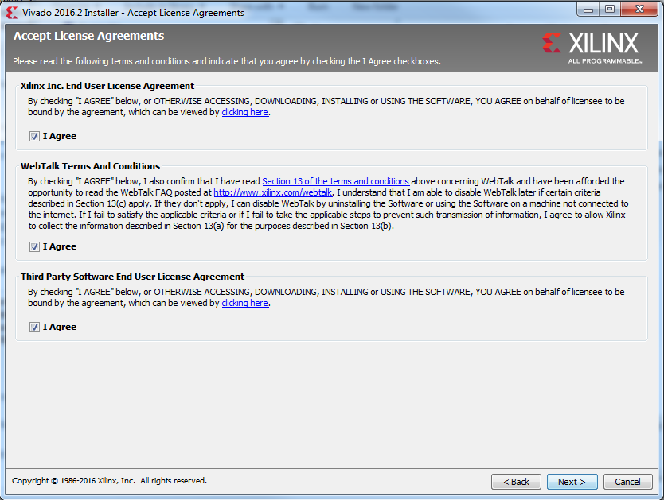

Select the Vivado HL **Design** Edition and click **Next**.

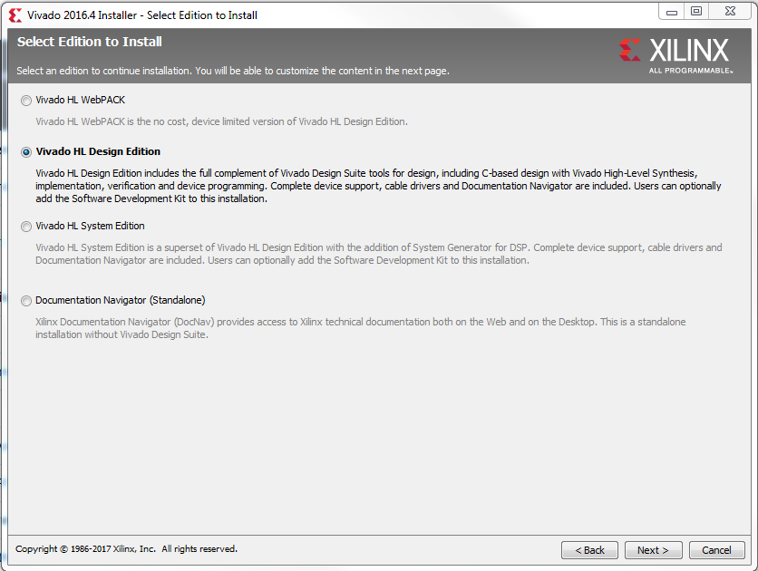

Notice that over 34 GB are required for the install! Following the directions below should reduce this significantly. Unfortunately, the required SDK adds another 12 GB…

* Check Software Development Kit (SDK)
* Uncheck all of the devices except the Artix-7.
* Disable WebTalk unless you plan on using the WebPACK license.
* Verify the settings match the below picture
* Click Next

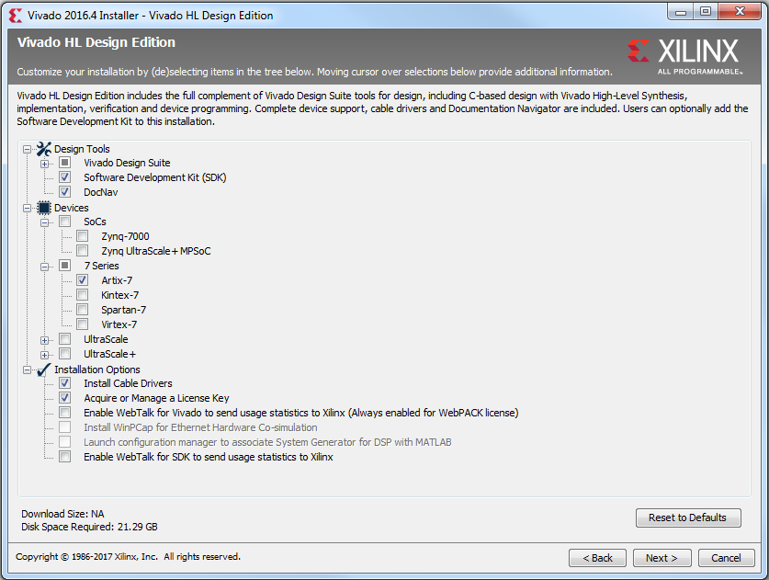

**Check SDK** and quietly weep as your HDD space is obliterated

**Uncheck WebTalk**

**Only this device family is needed**

**Select “All users”** for the file associations and click **Next** (does not apply to Vivado upgrade)**.**

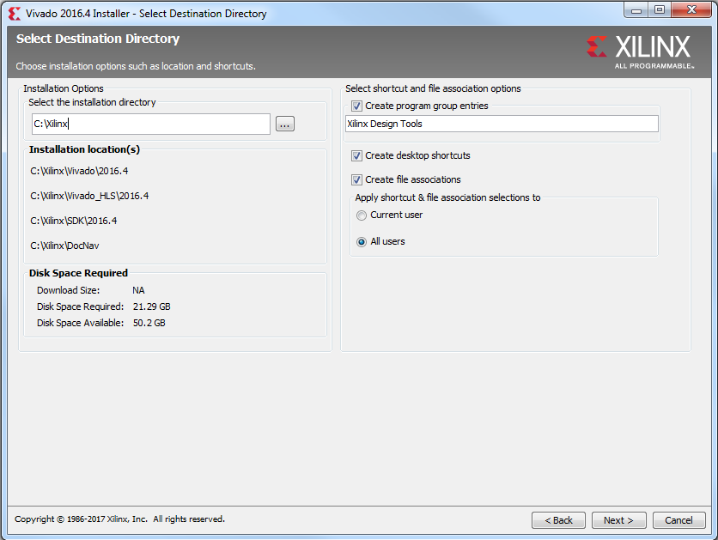

Verify that you are happy with the Installation Summary. It should be similar to the below picture.

Double check that you actually have *at least* the amount of disk space required as indicated in the circled portion of the image below. Maintaining at least 15% free space on your hard drive is ideal.

Click **Install**.

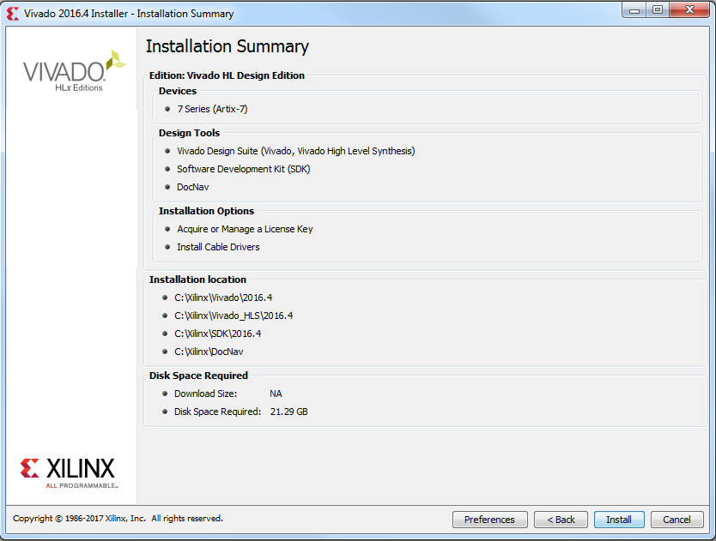

The install will take approximately 20 minutes on a good machine. If you are bored you can watch the adverts during the installation. A tasty sample is on the next page.

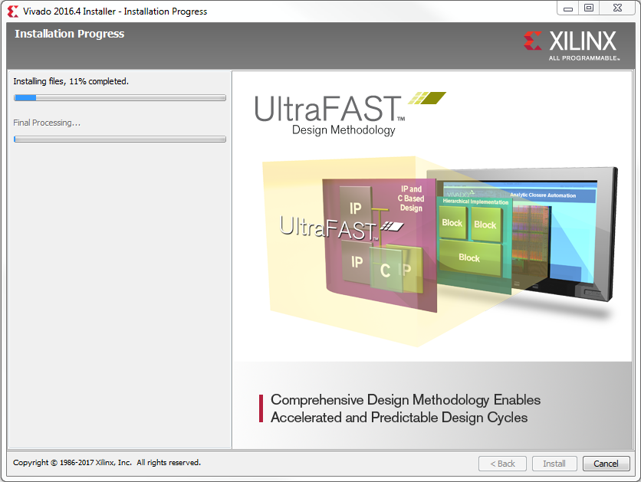

**Click OK** that you do not have any cables connected to a FPGA

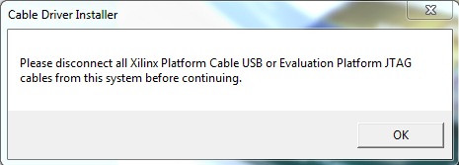

Hopefully you will get a success message that you can click away, and the Vivado license manager should pop up.

Click on “**Load License**” and then “**Copy License…**” as indicated in the circled portions in the image below.

Navigate to and select the **Xilinx.lic** file on the provided external hard drive. You can then close the License Manager.

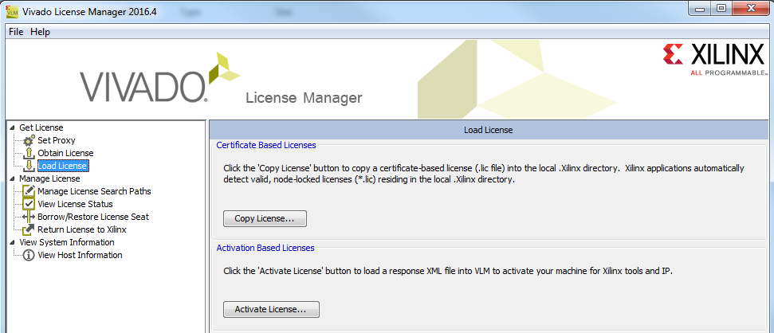

If you want to verify that you have a license you can reopen the License Manager from your Windows Start Menu.

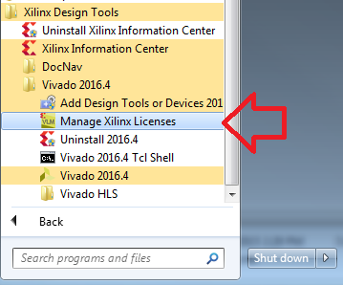

C:\Users\phillip.warner\Desktop\Vivado.pngCONGRATULATIONS! You have just installed a licensed version of Xilinx Vivado.

You can run it by clicking on the icon that looks like

# Board Support Files Installation

Unzip a copy of vivado-boards-master.zip from a provided external hard drive (or download a new copy from [GitHub](https://github.com/Digilent/vivado-boards/archive/master.zip).

Navigate within the unzipped folder to vivado-boards-master\new\board_files\ and copy the required (or all) of the folders into your Vivado board_files folder at a path similar to: C:\Xilinx\Vivado\2016.4\data\boards\board_files\

Restart Vivado if it was open.

For a more in depth tutorial, see <https://reference.digilentinc.com/reference/software/vivado/board-files>.